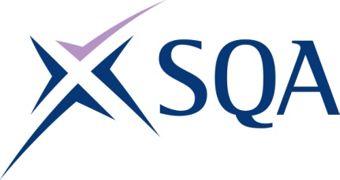

GA TITLE: SVQ Emergency Fire Services: Operations in the Community at SCQF Level 7
GA CODE: GT7D 23

SCQF overall credit: Minimum 126 Maximum 131
To attain the qualification candidates must complete 7 Units in total. This comprises:
- 6 mandatory Units
- 1 optional Units

Please note the table below shows the SSC identification codes listed alongside the corresponding SQA unit codes. It is important that the SQA unit codes are used in all your recording documentation and when your results are communicated to SQA

Mandatory units: Candidates must complete all 6 units from this group
SQA code | SSC code | Title | SCQF level | SCQF credits | SQA credits
H9FF 04 | SFJFRSFF1 | Educate your community to improve awareness of fire and rescue safety matters | 6 | 11 | 1
FA6J 04 | SFJFRSFF2 | Take responsibility for effective performance in fire and rescue | 7 | 10 | 1
H9FC 04 | SFJFRSFF3 | Search for, rescue and support endangered life | 7 | 32 | 1
J6N4 04 | SFJFRSFF4 | Resolve fire and rescue operational incidents | 7 | 37 | 1
H9FD 04 | SFJFRSFF5 | Protect life and the environment from the effects of hazardous materials | 6 | 11 | 1
H9FE 04 | SFJFRSFF6 | Maintain readiness for fire and rescue operational response | 6 | 15 | 1

Optional Units: Candidates must complete 1 unit from this group
SQA code | SSC code | Title | SCQF level | SCQF credits | SQA credits
FA6N 04 | SFJFRSFF7 | Support the development of colleagues in fire and rescue | 7 | 10 | 1
H9FG 04 | SFJFRSFF8 | Contribute to fire safety solutions to minimise risks | 7 | 15 | 1
H9FH 04 | SFJFRSFF9 | Drive fire and rescue service vehicles | 7 | 13 | 1

