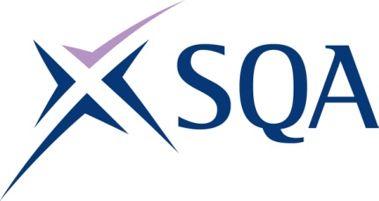

Group Award Title: Diploma in Digital Technology: Software Development at SCQF
level 8

Group Award Code: GT91 48

SCQF overall credit: Minimum: 95 Maximum: 95
To attain the qualification, candidates must complete 8 Units. This consists of:

- eight mandatory units.

Please note the table below shows the SSC identification codes listed alongside the corresponding SQA unit codes. It is important that SQA unit codes are used in all your recording documentation, and when your results are communicated to SQA.

Mandatory units: Total of eight mandatory units required
SQA code | SSC code | Title | SCQF  level | SCQF  credits | SQA  credits
J6VC 48 | SDS 187 | Supporting Digital Business Transformation | 8 | 9 | 1.5
J6TS 48 | SDS 007 | Applying Methods and Principles in Project Management | 8 | 12 | 2
J6V0 48 | SDS 012 | Developing Meta-Skills and Personal Professionalism | 8 | 16 | 2.5
J6V3 48 | SDS 021 | Implementing Software Methodology | 8 | 10 | 1.75
J6TY 48 | SDS 018 | Designing Software | 8 | 12 | 2
J6V1 48 | SDS 019 | Developing Software | 8 | 16 | 2.5
J6VA 48 | SDS 031 | Providing Software Testing and Assurance | 8 | 10 | 1.75
J6VB 48 | SDS 030 | Providing User and Software Documentation | 8 | 10 | 1.75

