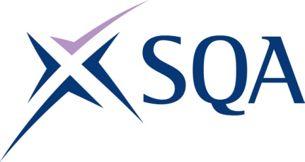
GV1R 22 | SVQ in Steelfixing Occupations (Construction) at SCQF level 5

To attain the qualification candidates must complete five units in total. This comprises:

- three mandatory units
- two optional units

Please note the table below shows the SSC identification codes listed alongside the corresponding SQA unit codes. It is important that the SQA unit codes are used in all your recording documentation and when your results are communicated to SQA.

Mandatory units: Learners must complete three mandatory units
SQA code | SSC code | Title | SCQF level | SCQF credits | SQA  credits
HL7R 04 | COSVR641v2 | Conform to General Workplace Health, Safety and Welfare | 6 | 12 | 1
HL7T 04 | COSVR642v1 | Conform to Productive Work Practices | 5 | 5 | 1
HM15 04 | COSVR643v1 | Move, Handle or Store Resources | 5 | 5 | 1
Optional Units – learners must achieve two optional units
J7A0 04 | COSVR166v4 | Cut and Bend Reinforcement Steel to Shape | 5 | 16 | 1
J7A1 04 | COSVR534v3 | Fix Steel in-situ | 5 | 22 | 1
J7A2 04 | COSVR535v3 | Prefabricate Reinforcement Steel Sections | 5 | 25 | 1

