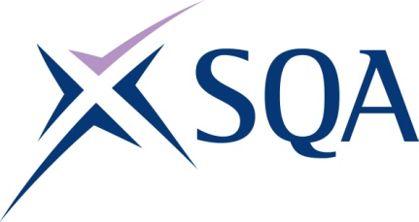

Group Award Title: SVQ in Emergency Fire Services: Control Operations at SCQF level 7

Group Award Code: GT8W 23

SCQF overall credit: Minimum: 126 Maximum: 142
To attain the qualification, candidates must complete 8. This consists of:

- 6 Mandatory Units
- 2 optional Units

Please note the table below shows the SSC identification codes listed alongside the corresponding SQA unit codes. It is important that SQA unit codes are used in all your recording documentation, and when your results are communicated to SQA.

Mandatory units: Candidates must complete all six units
SQA code | SSC code | Title | SCQF  level | SCQF  credits | SQA  credits
J6SM 04 | SFJFRSCO1 | Maintain Information on Fire and Rescue Operational Resources | 7 | 17 | 1
J6SN 04 | SFJHA203 | Manage Personal Development and Reflect on Current Practice | 7 | 8 | 1
J6SP 04 | SFJFRSCO3 | Gather and Manage Information to Mobilise a Fire and Rescue Response | 7 | 33 | 1
J6SR 04 | SFJFRSCO4 | Support Fire and Rescue Responses | 7 | 20 | 1
J6SS 04 | SFJFRSCO6 | Manage Fire and Rescue Information to Support the Needs of Your Community | 7 | 20 | 1
J6ST 04 | SFJFRSCO5 | Monitor and Manage the Reliability and Readiness of Fire and Rescue Control Operations and Equipment | 6 | 7 | 1

Optional Group: Candidates must select two units
SQA code | SSC code | Title | SCQF  level | SCQF  credits | SQA  credits
H55X 04 | SFJC07 | Specialist or Bespoke Software | 6 | 14 | 1
FA6N 04 | SFJFRSFF7 | Support the Development of Colleagues in Fire and Rescue | 7 | 10 | 1
H9FH 04 | SFJFRSFF9 | Drive Fire and Rescue Service Vehicles | 7 | 13 | 1
J6SV 04 | SFJAB101 | Communicate Effectively with Callers to Emergency Services | 7 | 15 | 1
J6SW 04 | SFJCD201 | Respond to Emergency Service Calls | 7 | 15 | 1
J6SX 04 | SFJCD202 | Assess, Prioritise and Manage Emergency Service Calls | 7 | 15 | 1
J6SY 04 | SFJCD203 | Deploy Resources to Respond to Emergency Situations and Incidents | 7 | 19 | 1
J6T1 04 | SFJZH13 | Operate Telephony and Computerised Systems for Emergency Services | 6 | 18 | 1
H9FF 04 | SFJFRSFF1 | Educate Your Community to Improve Awareness of Fire and Rescue Safety Matters | 6 | 11 | 1

