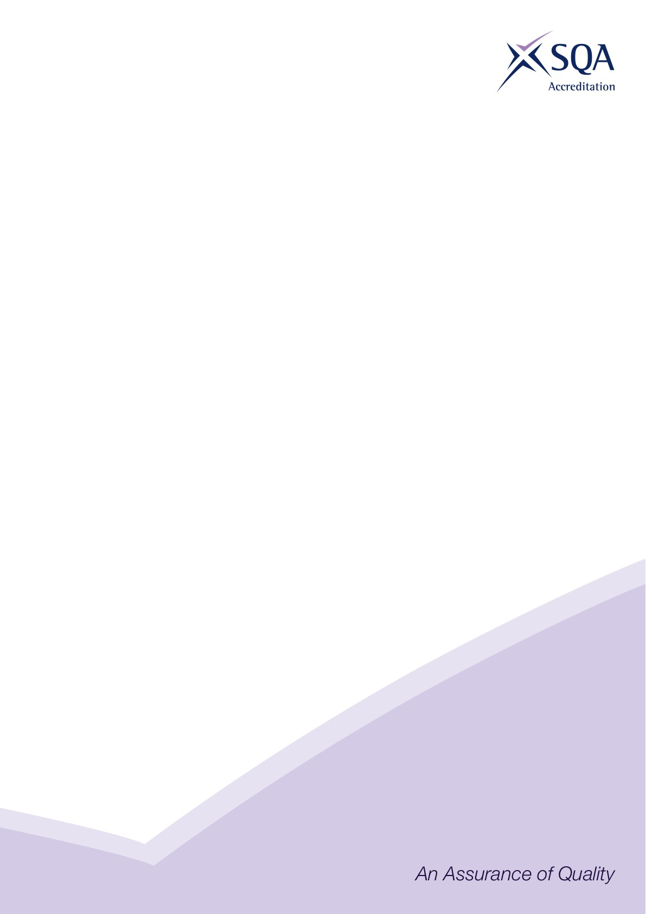

**Core Skills Signposting**

|  |  |
| --- | --- |
| **Sector** | Construction |
| **Qualification Title(s)** | SVQ in Insulation and Building Treatments (Construction) at SCQF Level 6 |
| **Developed by** | CITB |
| **Approved by ACG** | Wednesday 10 March 2021 |
| **Version** | 1 |

## Introduction

Core Skills signposting indicates if there are opportunities within units to develop Core Skills in the workplace to a specified SCQF level. The signposting document should also acknowledge where there are no opportunities to develop Core Skills. This signposting can be used by providers and assessors to plan the development and assessment of Core Skills.

The five Core Skills are:

◻ Communication

◻ Information and Communication Technology

◻ Numeracy

◻ Problem Solving

◻ Working with Others

*SSO may insert additional introductory text to contextualise the core skills signposting to their sector*

## Core Skills Signposting

|  |  |  |  |  |  |  |
| --- | --- | --- | --- | --- | --- | --- |
| **SVQ in Insulation and Building Treatments (Construction) at SCQF level 6** | | | | | | |
| **Ref No.** | **Title** | **Communication** | **ICT** | **Numeracy** | **Problem solving** | **Working with others** | |
| COSVR209v2 | Confirm work activities and resources for the work | Level 5 | Level 5 | Level 5 | Level 5 | Level 5 | |
| COSVR210v3 | Develop and maintain good working relationships | Level 5 |  |  | Level 5 | Level 5 | |
| COSVR211v2 | Confirm the occupational method of work | Level 5 |  | Level 5 | Level 5 | Level 5 | |
| COSVR250v2 | Erect and dismantle access/working platforms | Level 4 |  | Level 4 | Level 4 | Level 4 | |
| COSVR448v4 | Install external wall insulation | Level 5 | Level 5 | Level 5 | Level 5 | Level 5 | |
| COSVR449v4 | Apply surface finishes to external wall insulation | Level 5 | Level 5 | Level 5 | Level 5 | Level 5 | |
| COSVR451v4 | Install insulation to cold roofs | Level 4 | Level 4 | Level 4 | Level 4 | Level 4 | |
| COSVR641v2 | Conform to general workplace health, safety and welfare | Level 4 |  |  | Level 4 | Level 4 | |
| COSVR644v4 | Install internal insulation to walls | Level 5 | Level 5 | Level 5 | Level 5 | Level 5 | |
| COSVR645v4 | Install insulation to framed sections of buildings | Level 5 | Level 5 | Level 5 | Level 5 | Level 5 | |
| COSVR748v2 | Install insulation to create warm roofs | Level 4 | Level 3 | Level 4 | Level 4 | Level 4 | |
| COSVR749v2 | Install insulation to suspended floors | Level 4 | Level 4 | Level 4 | Level 4 | Level 4 | |
| COSVR812v1 | Spray insulation to create warm roofs | Level 4 | Level 4 | Level 4 | Level 5 | Level 5 | |
| COSVR813v1 | Blown insulation to cold roofs | Level 4 | Level 4 | Level 4 | Level 4 | Level 5 | |
| COSVR815v1 | Inject, blow and spray insulation to internal walls | Level 5 | Level 5 | Level 5 | Level 5 | Level 5 | |
| COSVR816v1 | Park Homes insulation | Level 5 | Level 5 | Level 5 | Level 5 | Level 5 | |
| COSVR817v1 | Insulation and Building Treatments (IBT) Building Construction, Defects and Interfaces | Level 5 | Level 5 | Level 5 | Level 5 | Level 5 | |
| COSVR818v1 | Spray insulation to suspended floors | Level 5 | Level 4 | Level 5 | Level 5 | Level 5 | |
| COSVR819v1 | Inject, blow or spray insulation to framed sections of buildings | Level 5 | Level 5 | Level 5 | Level 5 | Level 5 | |
| CFACSD1v2 | Develop customer relationships | Level 4 |  |  | Level 4 | Level 4 | |

*All numbers refer to SCQF level – any blanks indicate no opportunity.*