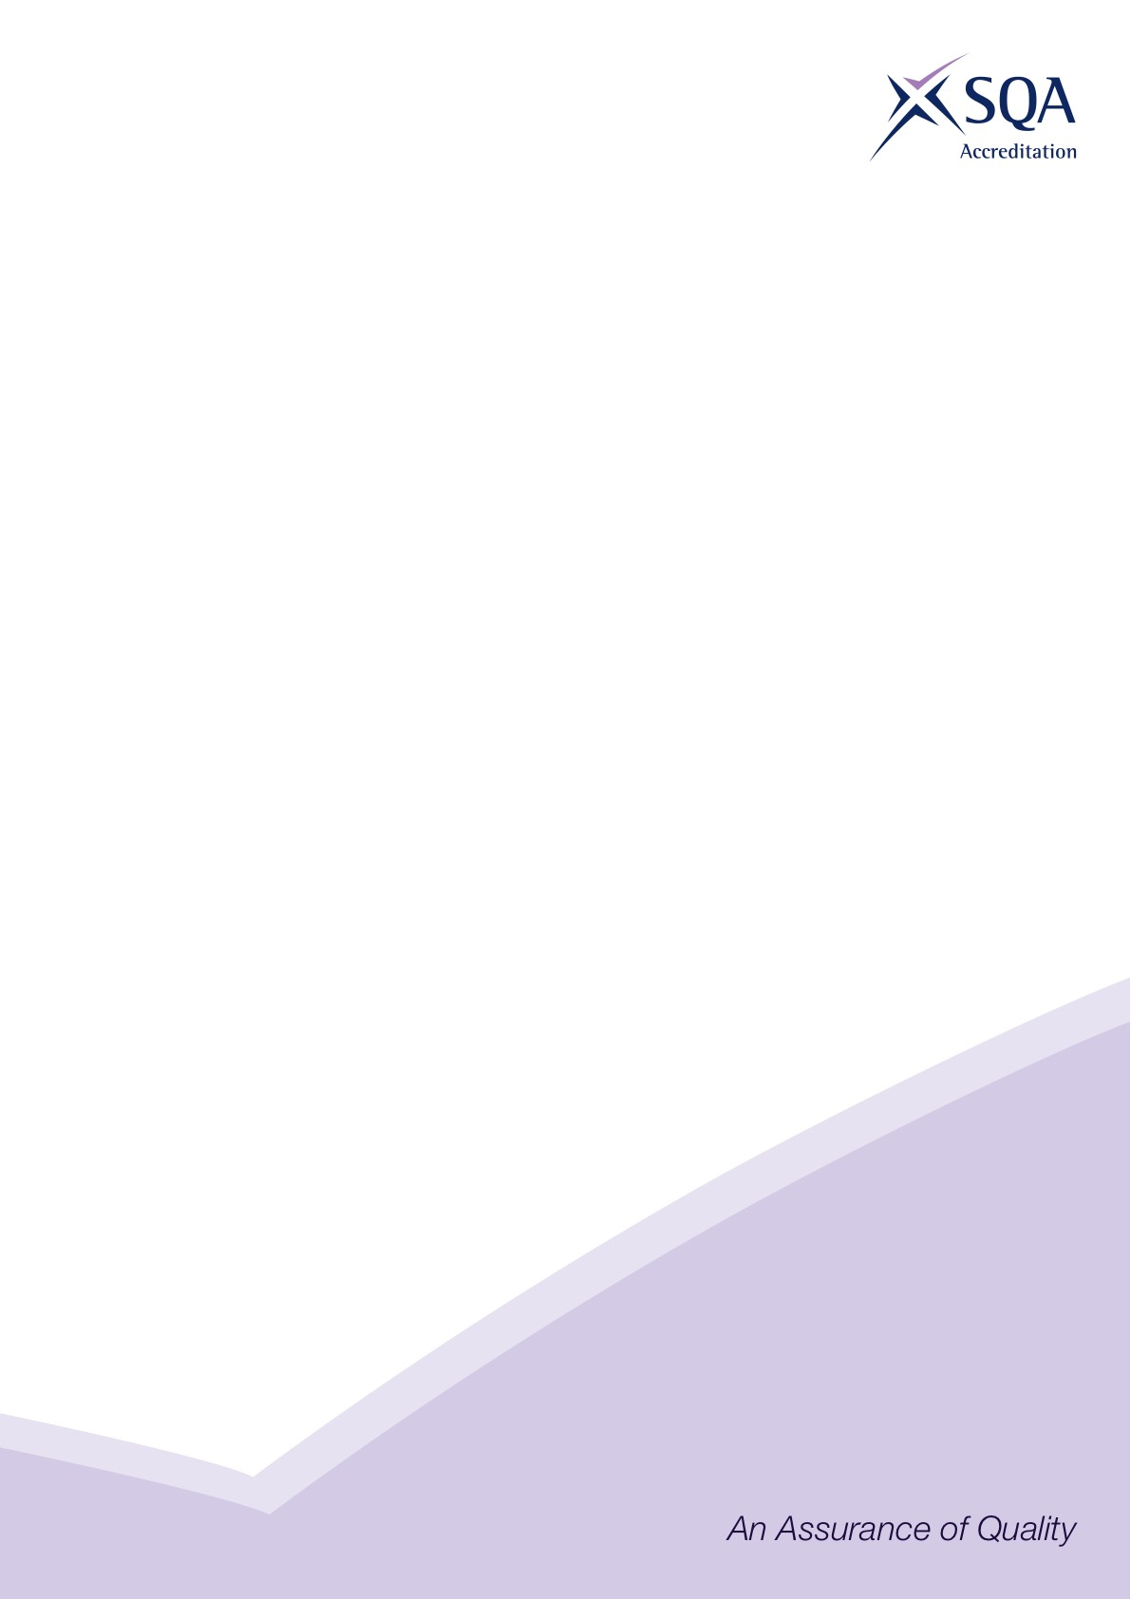

**Core Skills Signposting**

|  |  |
| --- | --- |
| **Sector** | Construction |
| **Qualification Title(s)** | SVQ Insulation and Building Treatments (Construction) at SCQF Level 5 |
| **Developed by** | CITB |
| **Approved by ACG** | Wednesday 10 March 2021 |
| **Version** | 1 |

## Introduction

Core Skills signposting indicates if there are opportunities within units to develop Core Skills in the workplace to a specified SCQF level. The signposting document should also acknowledge where there are no opportunities to develop Core Skills. This signposting can be used by providers and assessors to plan the development and assessment of Core Skills.

The five Core Skills are:

◻ Communication

◻ Information and Communication Technology

◻ Numeracy

◻ Problem Solving

◻ Working with Others

*SSO may insert additional introductory text to contextualise the core skills signposting to their sector*

## Core Skills Signposting

|  |  |  |  |  |  |  |
| --- | --- | --- | --- | --- | --- | --- |
| **SVQ in Insulation and Building Treatments (Construction) at SCQF level 5** | | | | | | |
| **Ref No.** | **Title** | **Communication** | **ICT** | **Numeracy** | **Problem solving** | **Working with others** |
| COSVR250v2 | Erect and dismantle access/working platforms | Level 4 |  | Level 4 | Level 4 | Level 4 |
| COSVR444v3 | Prepare structure for treatment | Level 4 |  | Level 4 |  | Level 4 |
| COSVR445v3 | Apply preservation treatment | Level 4 |  | Level 4 |  | Level 4 |
| COSVR446v3 | Reinstate the structure after building treatments | Level 4 |  | Level 4 |  | Level 4 |
| COSVR447v3 | Install wall ties in existing structures | Level 4 |  | Level 4 | Level 4 | Level 4 |
| COSVR450v4 | Install cavity wall insulation | Level 4 | Level 4 | Level 4 | Level 4 | Level 4 |
| COSVR451v4 | Install insulation to cold roofs | Level 4 | Level 4 | Level 4 | Level 4 | Level 4 |
| COSVR641v2 | Conform to general workplace health, safety and welfare | Level 4 |  |  | Level 4 | Level 4 |
| COSVR642v1 | Conform to productive work practices | Level 4 |  |  |  | Level 4 |
| COSVR643v1 | Move, handle or store resources | Level 4 |  | Level 4 | Level 4 | Level 4 |
| COSVR749v2 | Install insulation to suspended floors | Level 4 | Level 4 | Level 4 | Level 5 | Level 5 |
| COSVR814v1 | Install insulation to solid floors | Level 4 | Level 4 | Level 4 | Level 5 | Level 5 |
| COSVR817v1 | Insulation and Building Treatments (IBT) Building Construction, Defects and Interfaces | Level 5 | Level 5 | Level 5 | Level 5 | Level 5 |
| COSVR818v1 | Spray insulation to suspended floors | Level 4 | Level 4 | Level 4 | Level 5 | Level 5 |
| CFACSD1 v2 | Develop customer relationships | Level 4 |  |  | Level 4 | Level 4 |

*All numbers refer to SCQF level – any blanks indicate no opportunity.*