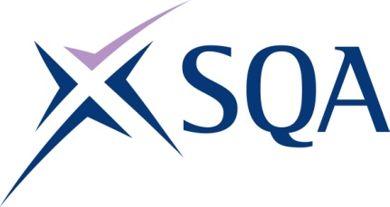

GT5X 22 SVQ in Thermal Insulation - Fit Protection (Construction) at SCQF Level 5

SCQF overall credit: Minimum 125 Maximum 125
To attain the qualification candidates must complete all 5 mandatory Units.

Please note the table below shows the SSC identification codes listed alongside the corresponding SQA unit codes. It is important that the SQA unit codes are used in all your recording documentation and when your results are communicated to SQA

Mandatory units: Candidates must complete all 5 units
SQA code | SSC code | Title | SCQF level | SCQF credits
J699 04 | COSVR322v3 | Apply Insulation and Finishes to Cylindrical and Flat Surfaces | 5 | 64
J69A 04 | COSVR324v3 | Fit Sheet Metal Insulation Protection | 5 | 39
HL7R 04 | COSVR641v2 | Conform to General Workplace Health, Safety and Welfare | 6 | 12
HL7T 04 | COSVR642v1 | Conform to Productive Work Practices | 5 | 5
HM15 04 | COSVR643v1 | Move, Handle or Store Resources | 5 | 5

