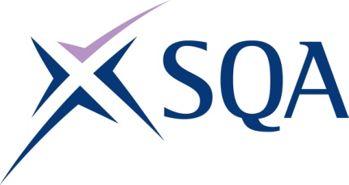

Level 2 Award in Utility Location and Avoidance in

Construction

SQA Qualification Code: GV7F 62

Regulation Qualification Code: 610/4993/1

Total Qualification Time: 20 hours

Minimum Guided Learning Hours (GLH) for whole qualification: 10 hours

To achieve this qualification, learners will need to complete 1 unit in total.

This comprises:

* 1 mandatory unit.

**Please note:** It is important that SQA unit codes are used in all your recording documentation, and when your results are communicated to SQA.

# Mandatory Core unit: Learners must achieve the unit below

| **SQA**  **Unit code** | **Title** | **Credit**  **value** | **Level** | **GLH** | **Regulated**  **Unit code** |
| --- | --- | --- | --- | --- | --- |
| J8N8 62 | Utility Location and Avoidance in Construction | 2 | 2 | 10 | **D/651/3969** |