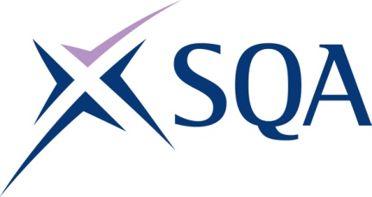
Group Award Title: SVQ in Hairdressing at SCQF level 5
Group Award Code: GV3T 22
SCQF overall credit: Minimum: 79 Maximum: 87
To attain the qualification, candidates must complete total of 8 units. This consists of:

- 6 mandatory units from Group A
- 1 unit from Group B
- 1 further unit from Group C or the remaining unit from Group B

Please note the table below shows the SSC identification codes listed alongside the corresponding SQA unit codes. It is important that SQA unit codes are used in all your recording documentation, and when your results are communicated to SQA.

Mandatory units: Group A (candidates must complete all six units)
SQA code | SSC code | Title | SCQF  level | SCQF  credits | SQA  credits
J7N5 04 | SKAHDBRBNS1 | Consult, Assess, Plan and Prepare for Hair, Barbering, Beauty, Nails, Wellbeing and Holistic Services | 6 | 7 | 1
J7N7 04 | SKAHDBRBNST1 | Implement and Maintain Safe, Hygienic and Effective Working Practices | 6 | 7 | 1
J7N9 04 | SKAHDBR1 | Shampoo, Condition and Treat the Hair and Scalp | 5 | 7 | 1
J7ND 04 | SKAHD1 | Set, Style and Dress Hair | 5 | 8 | 1
J7NF 04 | SKAHDBR5 | Colour and Lighten the Hair | 6 | 21 | 1
J7NG 04 | SKAHDBR18 | Cut and Clipper Hair using Hairdressing Techniques | 5 | 16 | 1

Optional groups:

Group B — a minimum of one unit must be selected
SQA code | SSC code | Title | SCQF  level | SCQF  credits | SQA  credits
J7NH 04 | SKAHDBR16 | Dry, Style and Finish Hair using Hairdressing Techniques | 5 | 8 | 1
J7NJ 04 | SKAHDBR9 | Braid, Twist and Thread Wrap Hair | 5 | 8 | 1

Group C — one unit must be selected or the remaining one unit from Group B
SQA code | SSC code | Title | SCQF  level | SCQF  credits | SQA  credits
J7PF 04 | SKAHDBR10 | Perm and Neutralise Hair | 6 | 12 | 1
J7P1 04 | SKAHDBR13 | Relax Hair Permanently | 6 | 13 | 1
J7PE 04 | SKAHDBR14 | Apply Temporary Hair Attachments to Enhance a Style | 5 | 5 | 1
J7NP 04 | SKAHDBRBNS2 | Provide Basic Business Support and Services | 5 | 10 | 1
J7NR 04 | SKAHDBRBNS3 | Instruct and Advise on Products and Services | 5 | 8 | 1

Template version: December 2022.

