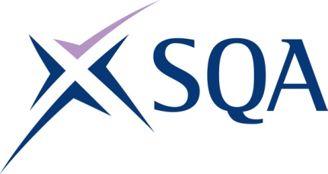
Group Award Title: SVQ in Barbering at SCQF level 5
Group Award Code: GV3W 22
SCQF overall credit: Minimum: 66 Maximum: 87
To attain the qualification, candidates must complete a total of 8 units. This consists of:

- 5 mandatory units
- 3 optional units - (a minimum of 1 must be chosen from Group B and the remaining 2 can be chosen from Group B or Group C)

Please note the table below shows the SSC identification codes listed alongside the corresponding SQA unit codes. It is important that SQA unit codes are used in all your recording documentation, and when your results are communicated to SQA.

Mandatory units: Group A (candidates must complete all five units)
SQA code | SSC code | Title | SCQF  level | SCQF  credits | SQA  credits
J7N5 04 | SKAHDBRBNS1 | Consult, Assess, Plan and Prepare for Hair, Barbering, Beauty, Nails, Wellbeing and Holistic Services | 6 | 7 | 1
J7N7 04 | SKAHDBRBNST1 | Implement and Maintain Safe, Hygienic and Effective Working Practices | 6 | 7 | 1
J7P8 04 | SKABR1 | Cut Facial Hair | 5 | 9 | 1
J7P9 04 | SKAHDBR19 | Cut and Clipper Hair using Barbering Techniques | 5 | 16 | 1
J7N9 04 | SKAHDBR1 | Shampoo, Condition and Treat the Hair and Scalp | 5 | 7 | 1

Optional groups:

Group B — a minimum of one unit must be selected
SQA code | SSC code | Title | SCQF  level | SCQF  credits | SQA  credits
J7PA 04 | SKAHDBR17 | Dry, Style and Finish Hair using Barbering Techniques | 5 | 8 | 1
J7NJ 04 | SKAHDBR9 | Braid, Twist and Thread Wrap Hair | 5 | 8 | 1

Group C — two units must be selected or the remaining one unit from Group B and one unit from Group C
SQA code | SSC code | Title | SCQF  level | SCQF  credits | SQA  credits
J7PC 04 | SKABR5 | Assist with Shaving Services | 4 | 7 | 1
J7PD 04 | SKABBR3 | Provide Non-strip Waxing Treatments for the Nostrils, Ears and Eyebrow Hair | 5 | 9 | 1
J7NF 04 | SKAHDBR5 | Colour and Lighten the Hair | 6 | 21 | 1
J7PE 04 | SKAHDBR14 | Apply Temporary Hair Attachments to Enhance a Style | 5 | 5 | 1
J7PF 04 | SKAHDBR10 | Perm and Neutralise Hair | 6 | 12 | 1
J7NP 04 | SKAHDBRBNS2 | Provide Basic Business Support and Services | 5 | 10 | 1
J7NR 04 | SKAHDBRBNS3 | Instruct and Advise on Products and Services | 5 | 8 | 1

Template version: December 2022.

