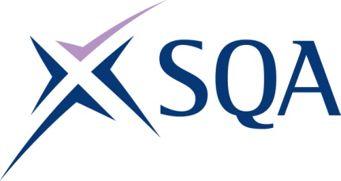

Group Award Title: SVQ in Learning and Development at SCQF level 8

Group Award Code: GV86 23

SCQF overall credit: Minimum: 43 Maximum: 55

To attain the qualification, candidates must complete a minimum of 6 Units. This consists of:

* 3 Mandatory Units
* Minimum of 1 Unit from the Group A optional Units
* As many Units as necessary from Group B to meet the min/max credits

Please note the table below shows the SSC identification codes listed alongside the corresponding SQA unit codes. It is important that SQA unit codes are used in all your recording documentation, and when your results are communicated to SQA.

# Mandatory units: Candidates must complete all 3 units

| **SQA code** | **SSC code** | **Title** | **SCQF**  **level** | **SCQF**  **credits** | **SQA**  **credits** |
| --- | --- | --- | --- | --- | --- |
| J8RW 04 | CLDLD04 | Plan and Prepare Specific Learning and Development Opportunities | 7 | 8 | 1 |
| J8RX 04 | CLDLD08 | Engage and Support Learners in the Learning and Development Process | 8 | 10 | 1 |
| J8RY 04 | CLDLD10 | Reflect on, Develop and Maintain Own Skills and Practice in Learning and Development | 7 | 4 |  |

# Optional group A: Candidates must complete at least one unit

| **SQA code** | **SSC code** | **Title** | **SCQF**  **level** | **SCQF**  **credits** | **SQA**  **credits** |
| --- | --- | --- | --- | --- | --- |
| J8T0 04 | CLDLD06 | Manage Learning and Development in Groups | 8 | 10 | 1 |
| J8T1 04 | CLDLD07 | Facilitate Individual Learning and Development | 8 | 11 | 1 |

# Optional group B: Candidates must complete as many as necessary (Note: candidates cannot count both J8RP 04 and J8RR 04 towards the SVQ)

| **SQA code** | **SSC code** | **Title** | **SCQF**  **level** | **SCQF**  **credits** | **SQA**  **credits** |
| --- | --- | --- | --- | --- | --- |
| J8T2 04 | CLDLD02 | Identify Individual Learning and Development | 8 | 8 | 1 |
| J8T4 04 | CLDLD05 | Develop and Prepare Resources for Learning and Development | 8 | 8 | 1 |
| J8T5 04 | CLDLD13 | Evaluate and Improve Learning and Development Provision | 9 | 12 | 1 |
| J8RP 04  or  J8RR 04 | CLDLD9D  or  CLDLD9DI | Assess Learner Achievement in the Workplace Using Direct Methods  **OR**  Assess Learner Achievement in the Workplace Using Direct and Indirect Methods | 7  8 | 8  10 | 1  1 |
| H41X 04 | CFAM&LDC3 | Mentor Individuals | 6 | 5 | 1 |
| J8RN 04 | CFAM&LDC4 | Coach Individuals | 7 | 6 | 1 |

Template version: December 2022.