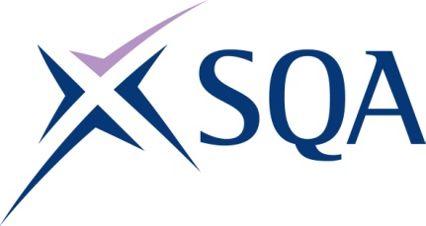

Dioploma ann am Meadhanan Cruthachail aig SCQF ire 7 (Diploma in Creative Media at SCQF level 7) – Structure

Group Award Code – GV73 47
To attain the qualification learners must complete 12 units in total. This comprises:
- 7 Mandatory units
- 5 Optional units

Please note the table below shows the SSC identification codes listed alongside the corresponding SQA unit codes. It is important that the SQA unit codes are used in all your recording documentation and when your results are communicated to SQA.
You can download the unit by clicking on the unit title.

Mandatory units: Candidates must complete 7 units from this group
SQA code | SSC code | Title | SCQF level | SCQF credits
J3Y3 04 | CDM1 | Present Ideas and Information to Others in the Creative Industries | 7 | 6
J3Y4 04 | CDM2 | Work Effectively with Others in the Creative Industries | 6 | 4
J3Y5 04 | CDM3 | Develop Own Professional Practice in the Creative Industries | 7 | 6
J3Y6 04 | CDM4 | Manage Media Content, Data and Information | 6 | 6
J3Y7 04 | CDM5 | Comply with Legal Requirements for Creative Media | 7 | 7
J3Y8 04 | CDM6 | Manage and Market Yourself in the Creative Industries | 7 | 7
J465 04 | CDM7 | Ensure Responsibility for Actions to Reduce Risks to Health and Safety | 6 | 3

Optional units: Candidates must complete 5 units from this group
SQA code | SSC code | Title | SCQF level | SCQF credits
J3Y9 04 | CDM8 | Write Text-Based Material for Multi-Platform Use | 7 | 5
J3YA 04 | CDM9 | Support Pre-Production Activities on a Film or Television Production | 7 | 6
J3YB 04 | CDM10 | Identify Sources of Information and Present Findings to Meet a Research Brief | 6 | 5
J3YC 04 | CDM11 | Prepare Camera Equipment for the Production | 5 | 4
J3YD 04 | CDM12 | Ingest Material for Editing | 6 | 7
J3YE 04 | CDM13 | Record Audio | 7 | 5
J3YF 04 | CDM14 | Edit and Mix Audio Content | 7 | 6
J3YG 04 | CDM15 | Undertake Research for Radio and Audio Content | 6 | 5
J3YH 04 | CDM16 | Operate a Radio and Audio Studio | 6 | 7
J3YJ 04 | CDM17 | Present a Radio or Audio Programme or Podcast | 7 | 7
J3YK 04 | CDM18 | Prepare for and Conduct Interviews in Creative Media | 6 | 4
J3YL 04 | CDM19 | Comply with Codes of Conduct, Regulations and Standards when Working in Radio and Audio Content Creation | 7 | 6
J3YM 04 | CDM20 | Comply with Codes of Conduct, Regulations and Standards when Working in Journalism | 7 | 6
J3YN 04 | CDM21 | Undertake Technical Adjustments of Images | 6 | 7
J3YP 04 | CDM22 | Communicate Using Marketing/Sales Channels | 6 | 5
J3YR 04 | CDM23 | Record Audio and Video Material | 6 | 5
J3YS 04 | CDM24 | Edit Audio and Video Material | 7 | 6

